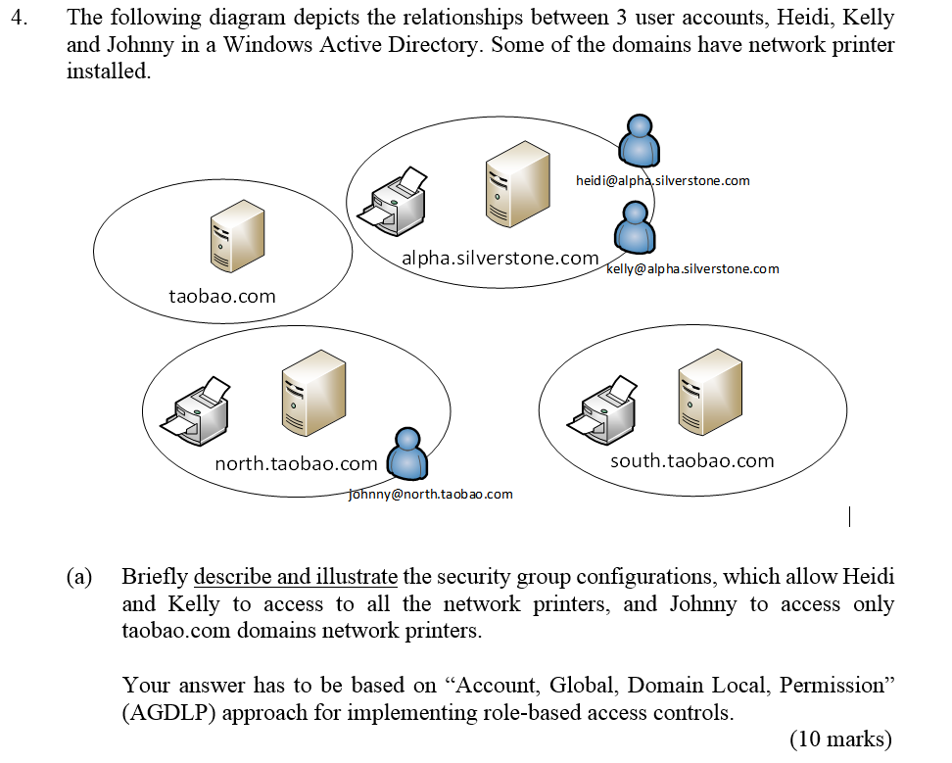

The following diagram depicts the relationships between 4 user accounts, Jack, Ben, Bob and Jennifer in a Windows Active Directory. There are total of 3 domains. Each of the domains has one network shared folder configured.



Briefly describe and illustrate the security group configurations, which allows all the user accounts to access to the shared folders resided in

* + - * 1. the same tree with read , write and delete the users' own files permissions.
        2. the other tree with only read permission.

Your answer has to be based on the “Account, Global, Domain Local, Permission” (AGDLP) approach to meet the above two access conditions.

To fulfil, AGDLP requires 4 accounts, 3 groups, 9 relationships, 6 domain local and 6 permissions